* **Activity 8:**

Updating Two Columns with a Subquery

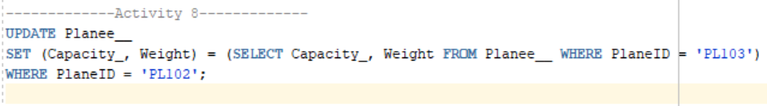

OUTPUT: